>
slabye rewenia sil`nye rewenia nelineinyx uravnenyi
Seysenbay Rustem MKM

> restart:
> with(plots);
Warning, the name changecoords has been redefined

Vvod ishodnnih danih

> F:=U->cos(u);
> U0:=x->sin(x);
reshenye uravnenia u-U0(u-f(x)t)=0;

> implicitplot (u-U0(x)), x=-1..1, u=-1..1);
Error, `)` unexpected

reshenia uravnenia u-U0(u-f(x)t)=0 pry t=0.7

> implicitplot (u-U0(x-diff(F(u),u)*0.7), x=-1..1, u=-1..1);
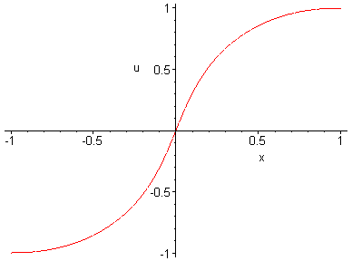
> P:=implicitplot((u-U0(x)=0, x=-1..1, u=-1..1)):
> R:=implicitplot((u-U0(x-diff(F(u),u)*0.7)=0, x=-1..1, u=-1..1),style=line,color=blue):

> display({P,R},axes=boxed,scaling=constrained,title='Uravnenie');
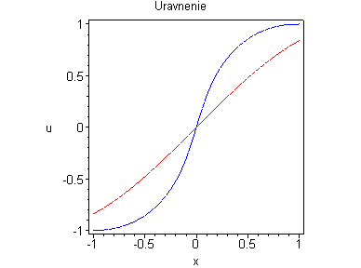
> A:=implicitplot((u-U0(x)=0, x=-1..1, u=-1..1)):
> B:=implicitplot((u-U0(x-diff(F(u),u)*0.1)=0, x=-1..1, u=-1..1),style=line,color=blue):
> C:=implicitplot((u-U0(x-diff(F(u),u)*0.2)=0, x=-1..1, u=-1..1),style=line,color=blue):
> E:=implicitplot((u-U0(x-diff(F(u),u)*0.3)=0, x=-1..1, u=-1..1),style=line,color=blue):
> T:=implicitplot((u-U0(x-diff(F(u),u)*0.4)=0, x=-1..1, u=-1..1),style=line,color=blue):
> Y:=implicitplot((u-U0(x-diff(F(u),u)*0.5)=0, x=-1..1, u=-1..1),style=line,color=blue):
> W:=implicitplot((u-U0(x-diff(F(u),u)*0.6)=0, x=-1..1, u=-1..1),style=line,color=blue):
> N:=implicitplot((u-U0(x-diff(F(u),u)*0.7)=0, x=-1..1, u=-1..1),style=line,color=blue):
> M:=implicitplot((u-U0(x-diff(F(u),u)*0.8)=0, x=-1..1, u=-1..1),style=line,color=blue):
> K:=implicitplot((u-U0(x-diff(F(u),u)*0.9)=0, x=-1..1, u=-1..1),style=line,color=blue):
> display, animate((A,B,C,E,T,Y,W,N,M,K),axes=boxed,scaling=constrained);
Error, (in animate) Third argument must be a range in this case

> ?animate
> animate((u-U0(x), x=-1..1, u=-1..1),frames=50);
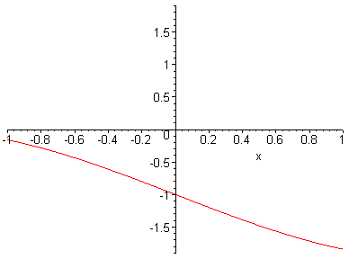
> animate ((u-U0(x-diff(F(u),u)*0.9), x=-1..1, u=-1..1),frames=50);



